**HTML5 Storage and Web Worker (Module 8 and 10)**

1. Create a login page (i.e. login.html) with username, password and a login button. When user clicks on the login button, user will be redirected to another page (i.e. GroceryMall.html).

GroceryMall.html should contain list of grocery items. All the items should be stored in localStorage. Whenever user selects any item from the list, that item should be appended to a div which is displaying the items you have selected, as well as add the selected items to the session storage. When user closes the webpage, all the sorcery items should be available with local storage and all the items should be clear.

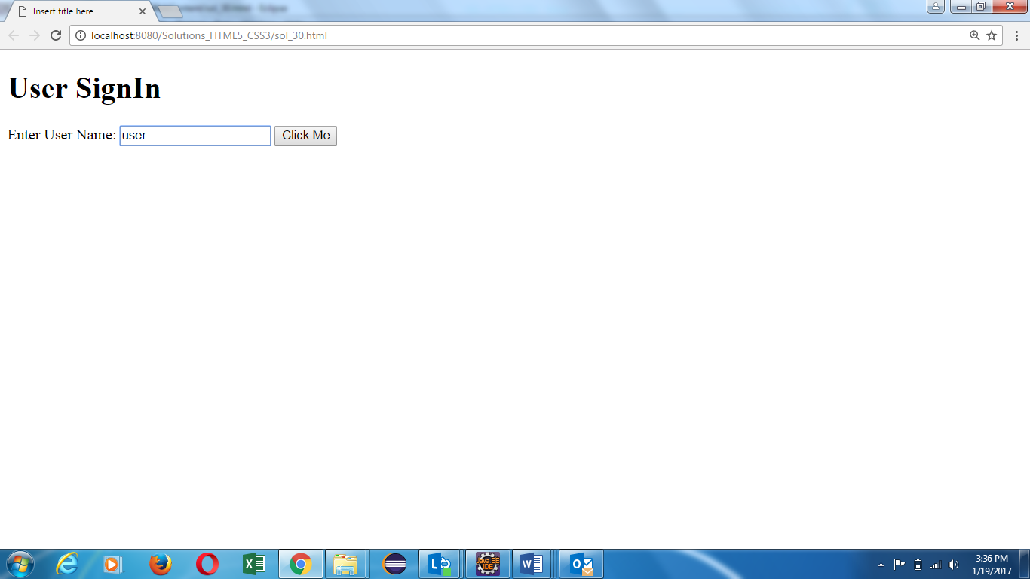

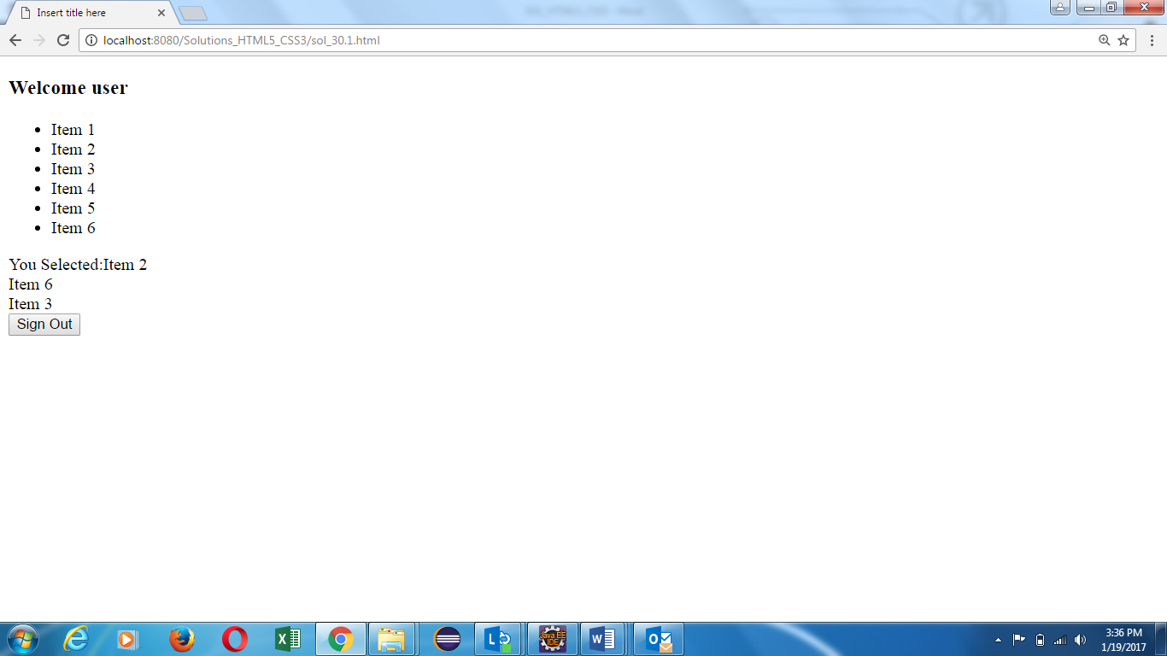

1. Create a webpage and display the number of visitors to that webpage. Create a variable that increments whenever that webpage is visited. Use local storage to store that variable.
2. Create an application using web workers to to print the odd numbers, where user is able to enter the limit upto which odd numbers are required. There should be a stop button to terminate the worker in between its execution.

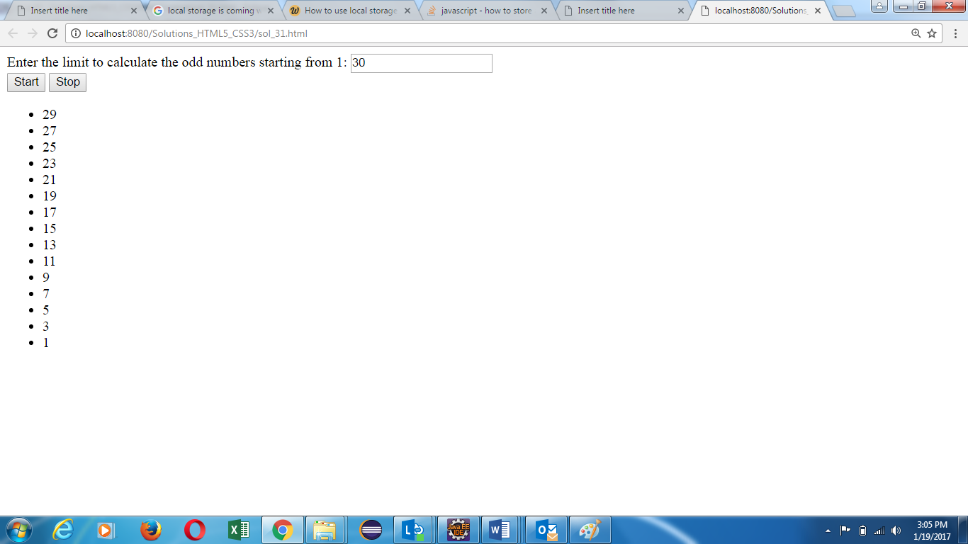

1. Create an application using web worker to display the mathematical tables from 2 to 10. Till the time worker is executing, display some loading message on the screen, which should not be there, once worker displays its result.

